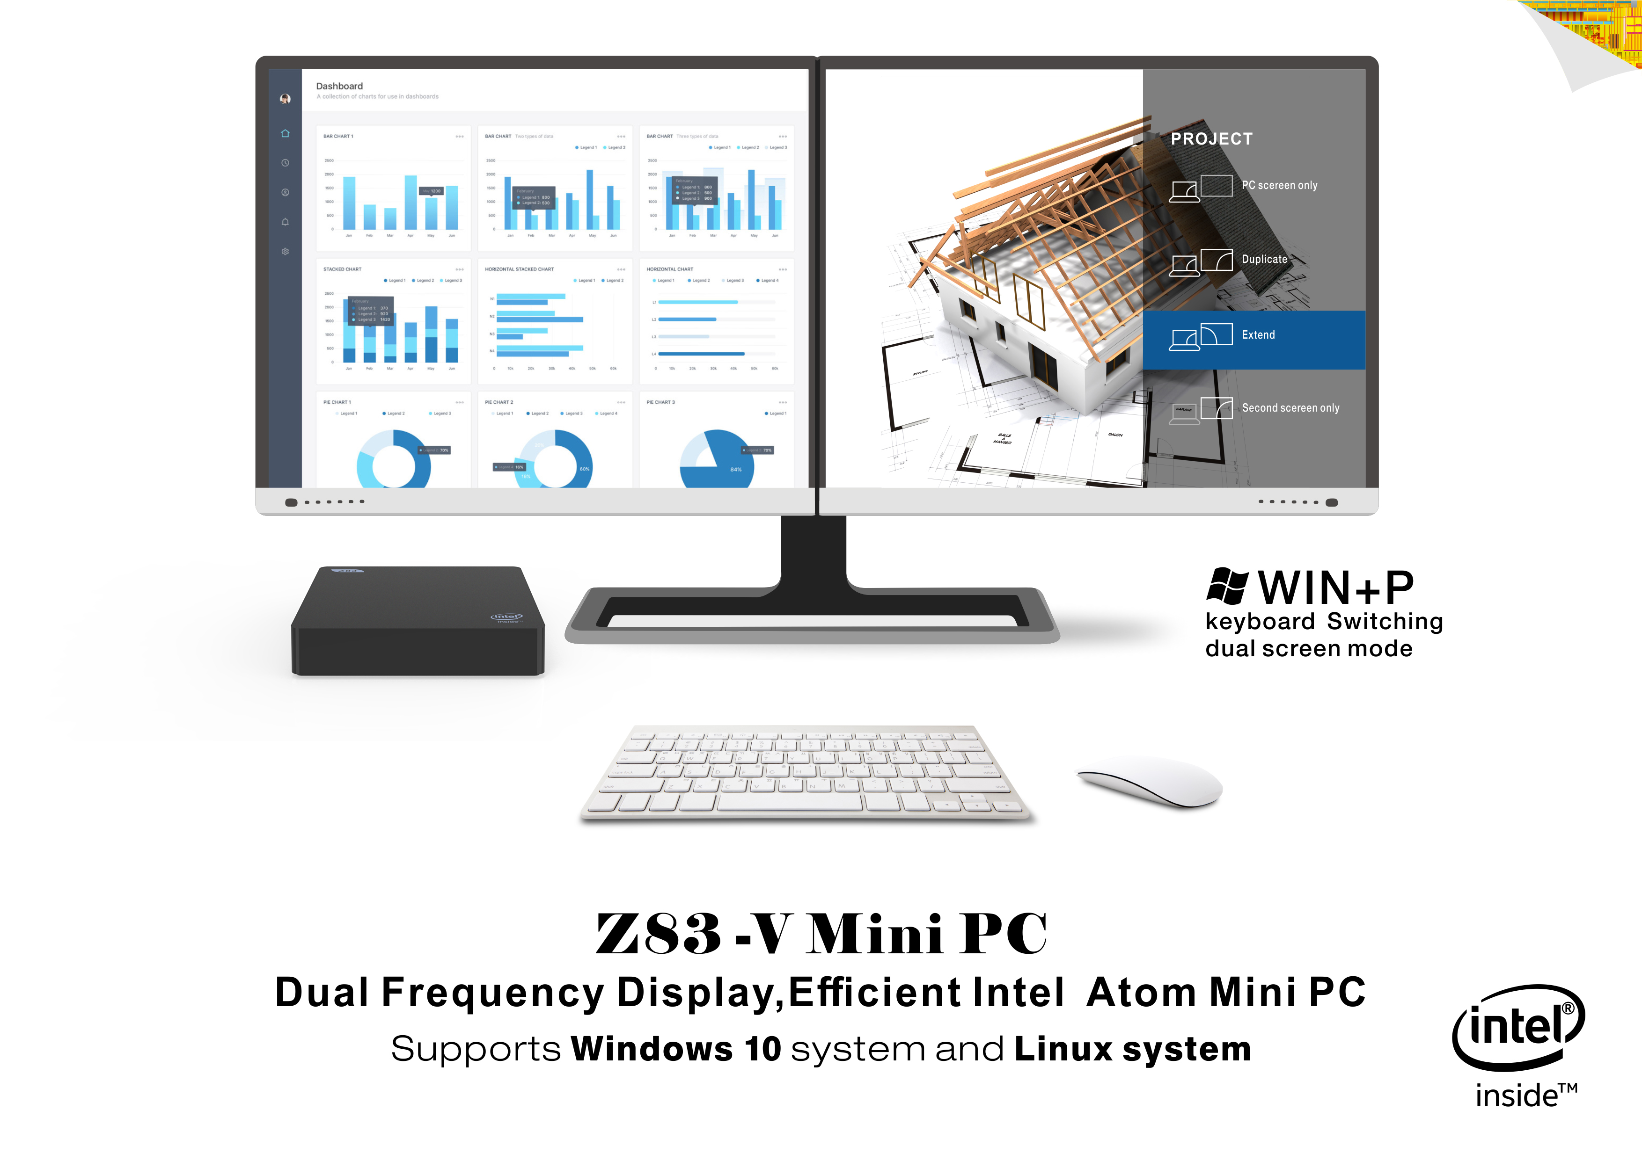

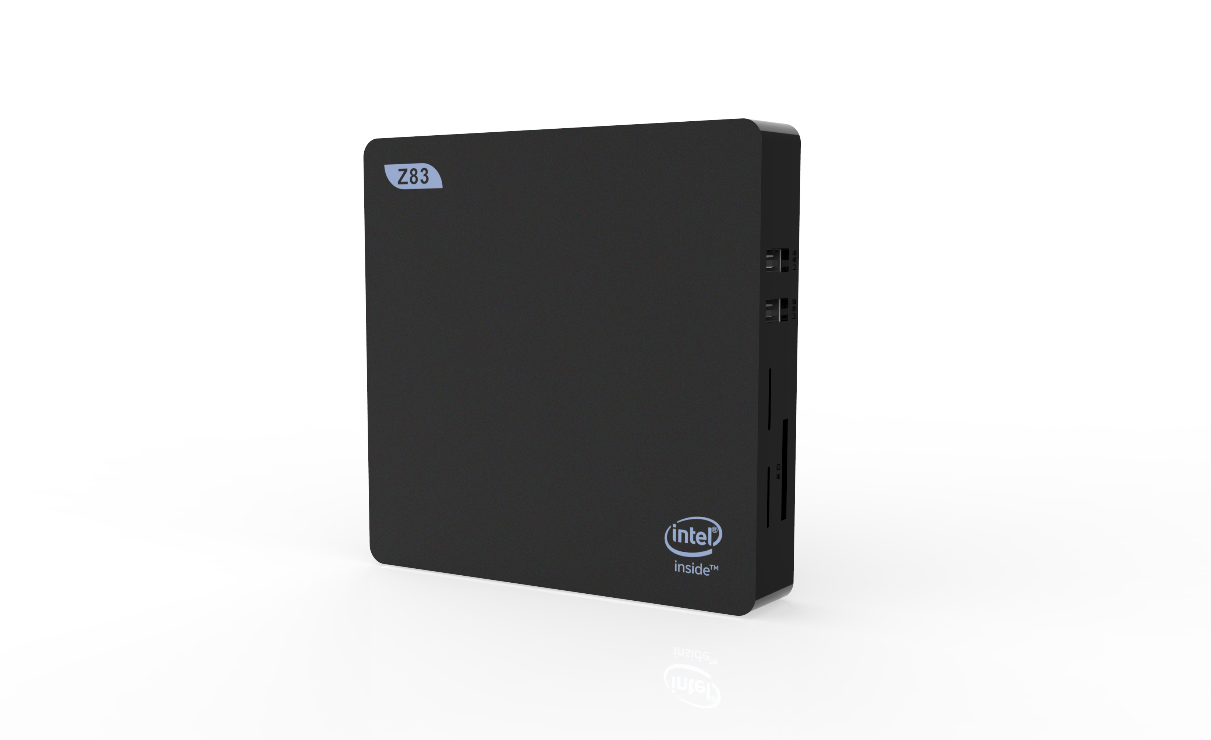
--
Specifications

Product Picture Show

Essentials

System Config

Performance

Button & Ports

Power management

Environment

Package Specifications

Advanced Technologies
Z83-V Mini PC Menu
Intel® Atom™ x5-Z8350 Processor
(2M Cache, up to 1.92 GHz)

Product Picture Show
Specifications
—

Specifications

Product Picture Show

Essentials

System Config

Performance

Button & Ports

Power management

Environment

Package Specifications

Advanced Technologies

Status | Launched
Launch Date | March 2017
Product model | Z83-V
Dimension | 119.5*119.5*24mm
Processor Number | x5-Z8350
Cache | 2 MB
Instruction Set | 64-bit

OS | Support Windows 10 system and Linux system
Language | Multi -language
Intel CPU | Intel Atom x5-Z8350 Processor  (2M Cache, up to 1.92 GHz)
Processor Graphics | Intel HD Graphics 400
Installed RAM | DDR3 2GB
System Disk | Windows(C:) 32GB
Ethernet | 1000Mbps LAN
WIFI | IEEE 802.11a/b/g/n，2.4G+5.8G
BT | BT 4.0
Antenna | Built-in antenna for WIFI
Expand Memory | SD Card (Support 128GB)
Dual screen display | Support

Essentials

System Config

Specifications

Product Picture Show

Essentials

System Config

Performance

Button & Ports

Power management

Environment

Package Specifications

Advanced Technologies

# of Cores | 4
# of Threads | 4
Processor Base Frequency | 1.44 GHz
Burst Frequency | 1.92 GHz
Scenario Design Power (SDP) | 2 W
Cache | 2 MB
Instruction Set | 64-bit

Button | 1*Power Button
DC-in | 1*DC in Port
USB3.0 | 1* Standard USB Port
HD | 1*HD Type Port
RJ45 | 1*RJ45 (1000Mbps network connection)
Headphone microphone | 1*Headphone microphone jack
SD Card | 1* SD card slot
USB2.0 | 2* Standard USB Port
VGA | 1* VGA Port
Power LED | 1* power LED

Power management | Adapter DC12V 1.5A(100-240V,50/60Hz)

Performance

Button & Ports

Power management

Specifications

Product Picture Show

Essentials

System Config

Performance

Button & Ports

Power management

Environment

Package Specifications

Advanced Technologies

Work Environment | 5°C -- 35°C，30%--90% Humidity
Storage Environment | -20°C -- 60°C，10%--90% Humidity

Packing size | 130*121*86.5mm

Intel 64-bit | yes
Intel Identity Protection Technology | yes
PRECAUTIONS FOR USE
- Failure to use the included Power Adapter may violate regulatory , compliance requirements and may expose the user to safety hazards.
- The system is installed as a clean version
- Support Windows 10 system and Linux system
- Do not use harsh of chemical solvent , Cleaning products , We recommend using a soft cloth to wipe
- Do not throw Product into fire , avoid having Fire accident
- Do not attempt to open the housing or to repair, if a failure occurs, please contact the customer service
- Please note seepage while clean electronics, be careful of electric shock.
- Check for any frayed or damaged cords or plugs.
- Don't arbitrary discard the product ,We should protect the environment
- Illegal system shutdown(Such as: directly unplug the power),May cause the operating system to crash.

Environment

Package Specifications

Advanced Technologies

--
--
--
--

